COUNTY GOVERNMENT OF MERU
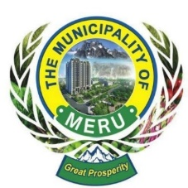
MERU MUNICIPALITY

ANNUAL CALENDAR FOR QUARTERLY CITIZEN FORA

1ST QUARTER (JANUARY - MARCH)
Theme: Development Priorities and Budget Planning
Date: Third Saturday of February
Time: 9:00 AM - 12:00 PM
Venue: Kamunde Hall
Agenda:
- Review the previous year's achievements and challenges.
- Discuss and prioritize development projects.
- Community input for budget allocation.

2ND QUARTER (APRIL - JUNE)
Theme: Infrastructure and Service Delivery
Date: Second Saturday of May
Time: 9:00 AM - 12:00 PM
Venue: Kamunde Hall
Agenda:
- Updates on ongoing infrastructure projects.
- Feedback on utility and public services (water, waste management, roads).
- Community concerns and suggestions for improvements.
3RD QUARTER (JULY - SEPTEMBER)
Theme: Health, Environment, and Safety
Date: Third Saturday of August
Time: 9:00 AM - 12:00 PM
Venue: Mjini Social Hall
Agenda:
- Public health updates and vaccination drives.
- Environmental initiatives (tree planting, waste management programs).
- Discussion on community safety and security measures.
4TH QUARTER (OCTOBER - DECEMBER)
Theme: Annual Review and Vision Setting
Date: First Saturday of December
Time: 9:00 AM - 12:00 PM
Venue: Nteere Park
Agenda:
- Review progress on annual goals.
- Community recognition and awards.
- Vision planning for the upcoming year.

