**MERU MUNICIPALITY**

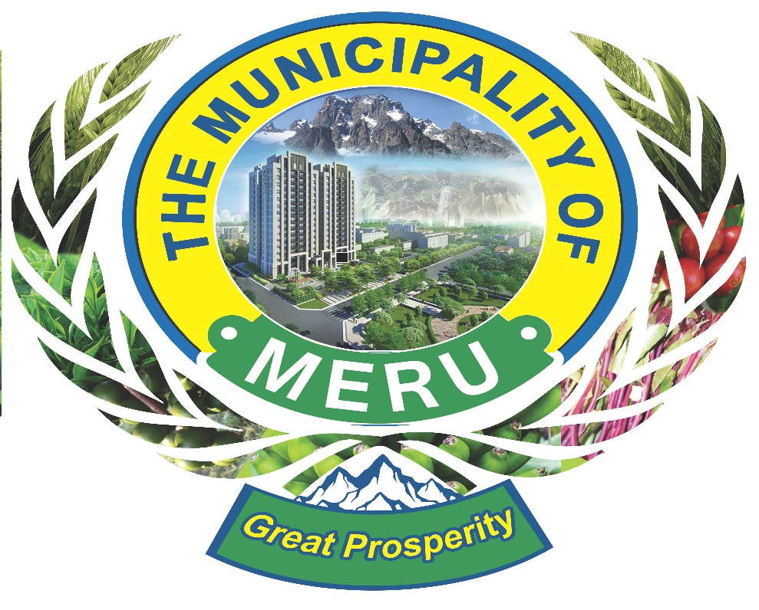

**MERU MUNICIPALITY ANNUAL INVESTMENT PLAN (2024/25)**

**MERU MUNICIPALITY ANNUAL INVESTMENT PLAN (2024/25)**

**Vision**

To establish Meru Municipality as a thriving, sustainable, and inclusive urban hub that fosters economic growth, infrastructure development, and social equity.

**Key Investment Areas**

**1. INFRASTRUCTURE DEVELOPMENT**

* **Roads and Transport**:
  + **Target**: Improve connectivity within the municipality and to surrounding regions.
  + **Projects**:
    - Upgrade 20 km of urban roads to bitumen standards.
    - Expand pedestrian walkways and cycling lanes by 10 km.
    - Develop modern and accessible public transport terminals to support urban mobility.
* **Water and Sanitation**:
  + **Target**: Achieve universal access to clean water and sanitation.
  + **Projects**:
    - Construct 5 additional boreholes in underserved areas, Mjini, Majengo and Salama
    - Expand sewer lines to cover 40% of the municipality's satellite towns.
    - Pilot a rainwater harvesting program.
    - Construction of sanitation blocks at the markets in the municipality

**2. Environmental Sustainability**

* **Target**: Protect natural ecosystems and address climate change.
* **Projects**:
  + Establish an urban afforestation program/nursery with the Kenya Forest Service (planting 50,000 trees).
  + Promote a solid waste management project, including a recycling plant.
  + Promote clean energy adoption through subsidies for solar lighting in public spaces.

**3. Economic Empowerment**

* **Target**: Create job opportunities and boost local enterprise.
* **Projects**:
  + Provide co-working spaces and high-speed internet for young innovators.
  + Partner with tech companies for coding boot camps and digital skills training.
  + Promote e-commerce platforms to market local products globally. Support small and medium enterprises (SMEs) through grants and training programs.

**4. Social Services**

* **Education**:
* **Target**: Ensure quality education for all.
* **Projects**:
* Increase financial aid for students from low-income families.
* Sponsor vocational training for out-of-school youth.

**The vulnerable and PWDS**

* **Target:** improve the livelihoods of the vulnerable and the PWDs
* **Projects:**
* Training and seminars for the vulnerable and PWDS on topical issues
* Vocational and life skills training for the vulnerable and PWDs
* Inclusion of the vulnerable and PWDs in citizen fora for municipal engagements

**Healthcare**:

* + **Target**: Enhance healthcare access and quality.
  + **Projects**:
    - Equip and upgrade 1 health centres to Level 4 hospitals.
    - Implement a maternal and child health outreach program.

**5. Governance and Urban Planning**

* **Target**: Strengthen governance and ensure orderly urban growth.
* **Projects**:
  + Digitize municipal services for transparency and efficiency.
  + Update the urban master plan to accommodate growth projections.
  + Train 40 municipal staff on governance and urban planning.

**Funding Sources**

* National Government Allocations
* County Contributions
* Public-Private Partnerships
* Development Partner Grants

**Implementation Framework**

* **Timeline**: Projects will be implemented in phases, starting with feasibility studies (Q1 2024) and full execution (Q2–Q4 2025).
* **Monitoring and Evaluation**:
  + Monthly progress reports by constituted county project teams.
  + Quarterly review meetings with stakeholders and partners.

**Expected Outcomes**

1. Enhanced infrastructure supporting a growing population.
2. Increased access to essential services, including clean water, health, and education.
3. Improved environmental conditions and resilience to climate change.
4. Economic growth through job creation and business support.
5. Strengthened municipal governance and transparency.